For this Pspice project, we were to simulate and optimize three types of Adders: two Mirror-type-Adders and one a TG-Adder type. We first started this project by writing the Pspice code of each one of the models using minimum size transistors. We tried both, .25um and .375um as minimum size. Once the adders were working properly with the expected output, we proceed to measure the values of propagation delay, power dissipation and others, with the objective of meeting as close as possible the specification of the project.

At first, the values obtained weren’t as close as we wanted them to be. Therefore, we had to proceed to use the learned techniques to achieve desired values. As stated in the book, the most useful technique in circuit design is transistor’s sizing. Therefore, we proceed to adjust transistors sizes reaching to improve propagation delay and power dissipation.

Our first objective was to reduce propagation delay. For that, we found the critical path of each of the adders and tried to reduce the time that the signal would take to propagate through that path –refer to appendix for critical path-. We tried to reduce the equivalent resistance of each one of the transistors that was involved in the propagation of the signal. We tried several values from ranges of .25um up to 2um, for both PMOS and NMOS transistors and we were able to reach desired numbers –actual values can be found in the attached plots-. We repeated the process for all the adders until we found values of propagation delay that were close to 1.0ns.

The next step was to reach specified average power consumption. By sizing transistors to reach low propagation delay, we found that by increasing the sizes of the transistors, we were also increasing the values of the parasitic capacitances. Therefore, initially, with relative small increase in values of the transistors, we were able to improve propagation delay at low cost of increase of power consumption. This trade of was the main constrain that shape our design. We found that if we increase the transistors size too much, the value of the parasitic capacitance was increasing at a greater rate than the reduction of resistance. There was a point were the propagation delay would increase with the increase of the size of the transistors. With this in mind, we had to find a point of equilibrium that would give us low propagation delay and low power consumption. The values we obtained can be found in the proper appendix in the Netlist code.

The overall performances of the three adders were pretty similar to each other. We found that we got best results with the Mirror Adder without inverters. This was due to its low power consumption, when compared to the TG-Adder and due to its low propagation delay, when compared to the Mirror Adder with inverters. The next best adder was the TG-Adder, because it gave us very low propagation delay, and also because it was build with less transistor gates than the other adders, we could assume that the power dissipation to leakage and static power dissipation would have had to be less than the others.
If the design were to be extended to 8-bits, the PDP would certainly increase. This is because the propagation delay would increase due to the increase in gates of the critical path; the parasitic capacitances, the static power consumption and the leakage current would also increase. All this values would deteriorate the performance of the circuit by increasing mainly propagation delay and over all power consumption.
The frequency of operation in this circuit would have to be reduced to assure the proper propagation of the signals. As know, when there is greater propagation delay, more time is needed to achieve stable results in the circuit. Therefore the frequency of operation is lower. In other words, there is less amount of operation that can be performed in time, and the circuit speed performance is lower.

Brief Discussion on Propagation Delay

This section briefly describes what effects of the inputs will have on our 4-bit adder. It describes the best case/worst case inputs (transitions).

The inputs that result in a best-case delay are those that do not create any generate signals in any of the fulladders. For example, the inputs can be: 0101 + 1010, or 1001 + 0110. In short, between any two pairs of inputs, if one is a 0, then the other has to be a 1. Graphically, this can be represented as:

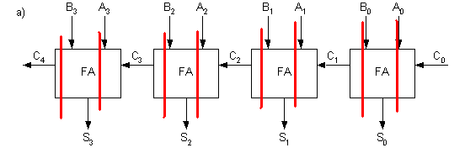
In the best case, the delay in the mirror adder, for instance, will simply be the time it takes to calculate the sum of the inputs of one full-adder. Since there is no ripple carry in any of the immediate stages, all the calculations will be done in parallel.
The inputs that result in a worst-case delay are those that do require a ripple carry to propagate through the immediate stages (C1 = C2 = C3 =1). The inputs that can generate this are 1111 + 1111 , or 1010 + 0101 with C0 =1. Graphically, this can be represented as:

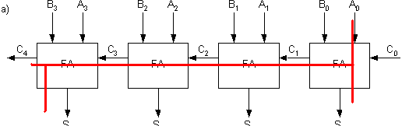
To calculate the delay in such a situation, we can reduce the full-adder to its component parts: namely, ripple-propagation, ripple-propagation, and sum-generation. The worst delay can be described as the time for a ripple-generate in the first stage, then ripple propagation in second, third stage, then sum generation in fourth and final stage. This gives the equation: A0->Co + 2*Cin->Co + Ci->S. *Note: an alternative equation can be A0->Co + 2*Cin->Co + Ci->C4. C4 is the overflow bit (to indicate summation overflow). But in our case, the overflow bit is ignored, so we consider the sum output at the fourth stage instead.

The way we calculate the delay through the circuit is by determining the equivalent capacitance at the output nodes (first order estimate.) We perform analysis for the worst case on the mirror adder. Please see the following hand calculations.

